Springfield Township

Parks and Land Management Plan

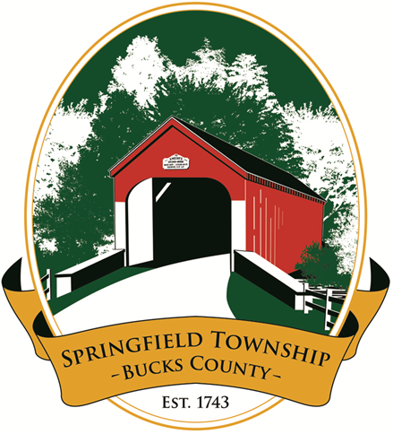

10 May 2021Table of Contents

1 Overview 3

1.1 Parks & Recreation Goals 3

1.2 Parks and Land Preservation Board (PLPB) 3

2 Parks (Community and School) including Greenspaces 3

2.1 Peppermint Park 3

2.2 Lime Kiln on Woodbyne Road Greenspace 3

2.3 Flagpole Memorial Garden 3

3 Trails (Part of Parks Type) 3

3.1 Upper Bucks Rail Trail 3

4 Programs 3

4.1 Youth Projects 3

4.2 Community Day 3

4.3 Volunteers / “Friends of the …” 3

4.4 Art in the Park – TBD 3

4.5 Springfield 5K / fun run – TBD 3

4.6 Bird / Nature walks – TBD 3

4.7 Donations and Sponsorships 3

4.8 Memorializing Citizens on Township Property– 3

5 Fiscal Responsibility 3

5.1 Permitted Uses 3

6 Appendix A – Maintenance Unit Types 3

6.1 Management Types by Facility 3

6.2 Management Types 3

7 Change Log 3

# Overview

## Parks & Recreation Goals

In 2012, the Springfield Township Board of Supervisors (BoS) initiated work on a Parks and Recreation Master Plan. The effort was facilitated by a paid consultant and involved a group of interested township citizens. The combined group surveyed township residents, worked to create the master plan, and facilitated a number of public forums throughout the township in order to gain feedback. The Master Plan was provided to the BoS in fall of 2013.

The Master Plan recommended four goals for Parks and Recreation:

* Parks – Establish parks and recreation facilities as community destinations where residents can have fun, experience nature, socialize, and lead active healthy lifestyles.
* Trails – Connect our community through a system of greenways and trails.
* Programs – Facilitate recreation opportunities to help the citizens engage in active healthy living.
* Fiscal responsibility – Provide operational excellence and financial sustainability that will garner widespread public support for parks and recreation.

The Master Plan defines Park types of Community Parks, School Parks, and Trails, so while the goals separate trails, they are included in the overall Park definition.

The Parks and Recreation Master Plan indicated that several properties within the township may be suitable to become part of the township Parks and Recreation. A Township Map indicating locations of Parks and Trails is depicted below.

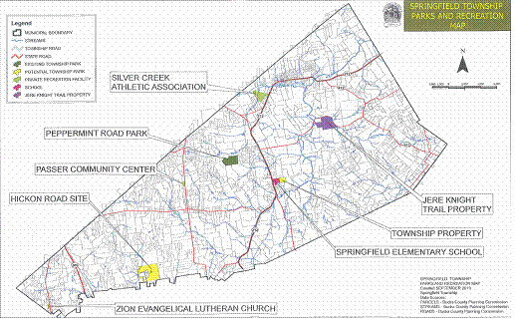

## Parks and Land Preservation Board (PLPB)

In May 2014, the Springfield Township BoS impaneled the Parks and Recreation Board (PRB) with the longer term objective of managing Parks and Recreation activities within the township and the near term goal of utilizing a PA state grant awarded to the township in November 2013. The grant was for $111K with a matching requirement and the goal of developing and establishing a Park on the Kurtesan property on Peppermint Road which the township had purchased in 2002. A topographical map from the 2002 purchase of the ~45 acre Kurtesan property is depicted below.

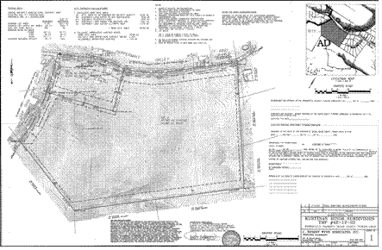

The PRB was eliminated by BoS on 1 July 2018 and the new Parks and Land Preservation Board (PLPB) was created by merging responsibility of the PRB and Open Space Committee. The PLPB started meeting officially in February 2020, maintains an annual budget and reports to the BoS. The township retains actual check writing and accounting responsibility.

# Parks (Community and School) including Greenspaces

## Peppermint Park

Park Name: Peppermint Park

Objectives: Passive recreation, land preservation

Dedicated: 23 April 2016

Description: in 2002, Springfield Township purchased a ~45 acre property along Peppermint and Deer Trail Roads which was part of the former Playland property. In 2013, the Township was awarded a State Grant to develop the property into the Township’s first park. The property consists of a ~5 acre woodlot, ~35 acres of open field, and ~5 acres including a parking lot, paved walking trail, a small ridge-top barrens biome, and a rain garden. Walking paths have been mowed into grass around the park and offer various lengths of trails via a series of loops. The park offers an approximate 200 foot elevation change from the bottom to the highest point. The view from the top of the hill looking northeast is captured in the photo below. Memorial benches have been installed at pre-coordinated sites around the park as depicted in the topographical map below.

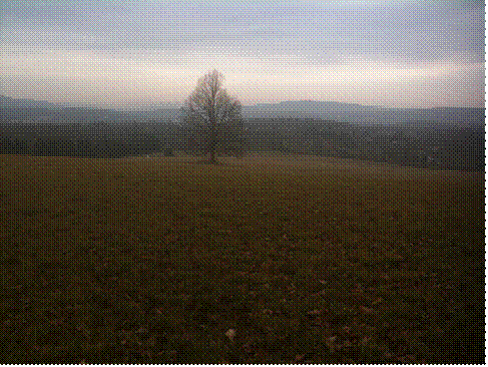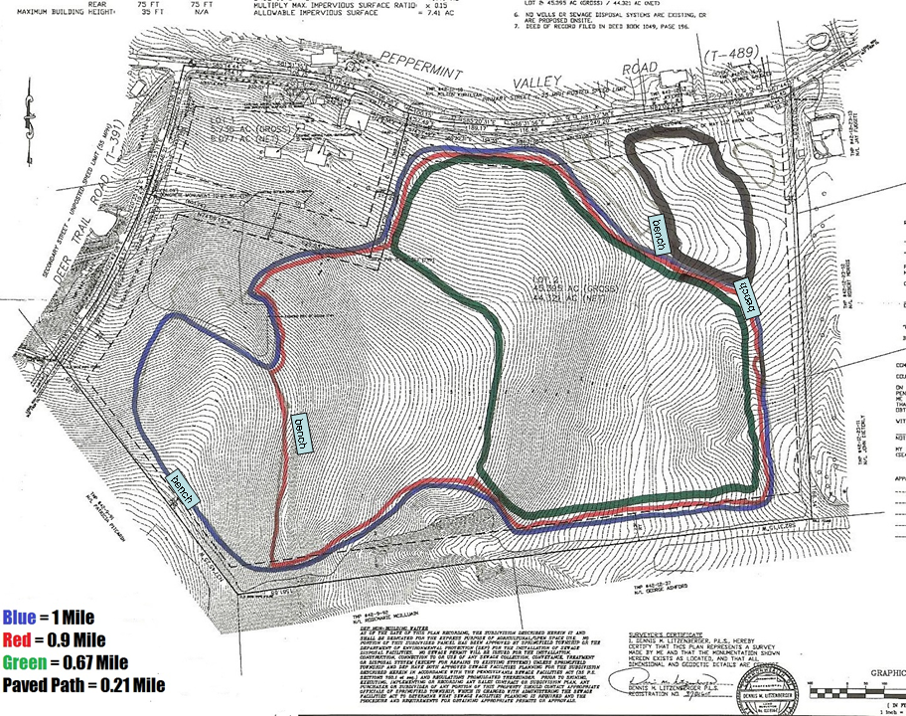

Table with listing of amenities

### Peppermint Park Management Units

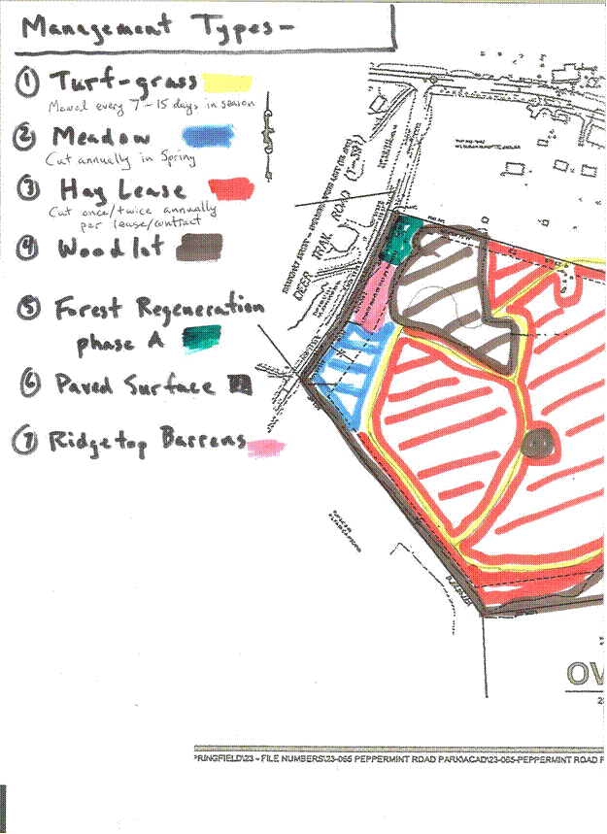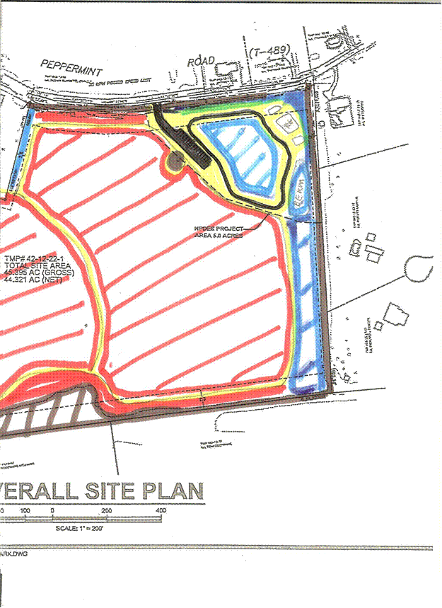

Management types for the park are indicated in the diagram above. A key for the major maintenance types is:

1. Turf grass (yellow areas)
2. Meadow (blue areas)
3. Hay Lease (red areas)
4. Woodlot (brown areas)
5. Reforestation (green area)
6. Paved Surface (black areas)
7. Ridge-top barrens biome (pink area)

Any formal use of the Park in Springfield Township would need approval by the PLPB via the Permit Process in section 5.1.3.

## Lime Kiln on Woodbyne Road Greenspace

Park Name: Lime Kiln

Objectives: Historic preservation, Passive recreation

Dedicated: 2018 TBD

Description: The PLPB is managing the Township owned property for the Lime Kiln on Woodbyne Road as greenspace and it may be a candidate for a future dedicated park. Springfield Township has ownership of a small plot of ground with a historic stone Lime Kiln in Springtown. The Township owned the property since 2014 Road dedication. This is the last known intact Lime Kiln in Springfield Township. The Lime Kiln was preserved with masonry work in 2018. The Springfield Township Historical Society has been instrumental in providing:

* Awareness,
* Education, and
* Initiation of fundraising to preserve the Lime Kiln

The Art of the Preservation effort has provided a donation to improve the Like Kiln site. The PLPB will consider a longer term approach to site development in the future.

Initial efforts focused on preservation of the Lime Kiln with subsequent creation of a master plan for the site and update of this management plan. A plot plan of the property and a photo of the Lime Kiln are below. Vegetation including several large trees with roots impinging on the Lime Kiln were removed in 2017. The plot was over seeded with grass seed to mitigate any erosion concerns and to control return growth of shrubs and trees. The PLPB supported masonry work to preserve the exposed portion of the Kiln.

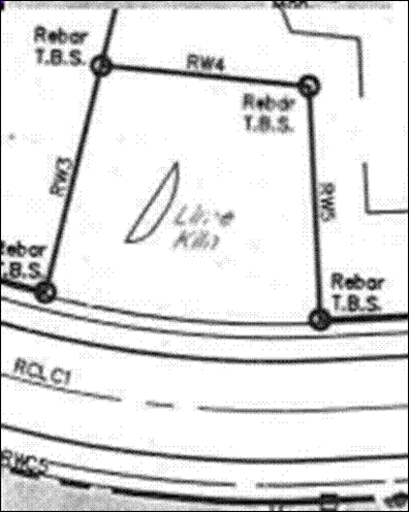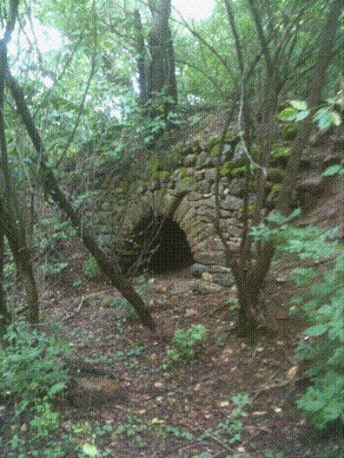

### Lime Kiln Management Units

The area around the Lime Kiln is managed as Turf Grass and maintained by mow and trim with approximately monthly weed whacking of the grass during the growing season. Two native cedar trees were returned to the property, after being saved prior to the tree clearing, and planted near the back two corner pins of the property.

## Flagpole Memorial Garden

Park Name: Flagpole Memorial Garden

Objectives: memorial, Passive recreation

Dedicated: 2009, rededicated May 2021 TBD

Description: Springfield Township has dedicated a memorial garden outside the Township Building by the Flagpole. The PLPB has undertaken a redesign of the space to embrace a low maintenance approach.

A draft plot plan design for the Flagpole Garden is included below. This draft plan was reviewed and approved by the Township Manager and Board of Supervisors. Site preparation work was started in 2020 with the construction of the new sidewalk and installation work is expected to take place in the spring of 2021.

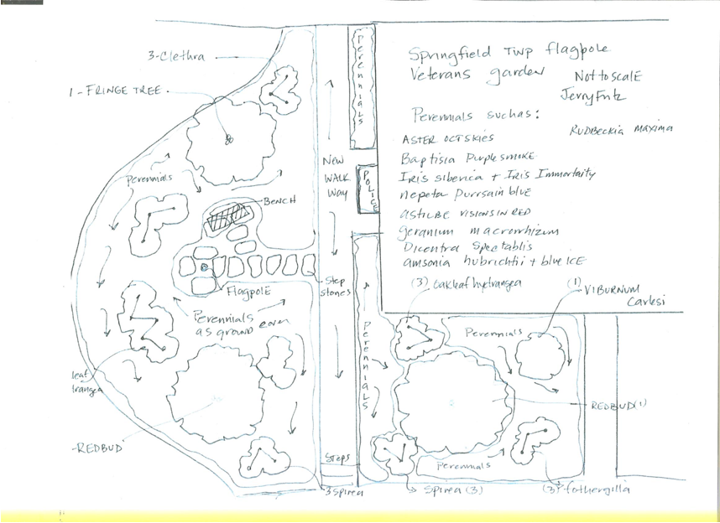

### Flagpole Garden Management Unit

The gardens are expected to be maintained with annual mulching. The vegetation is planned to primarily native perennials and shrubs. Annual flowering plants may be used in small doses near the building to provide color during the growing season.

# Trails (Part of Parks Type)

## Upper Bucks Rail Trail

Trail Name: Upper Bucks Rail Trail (UBRT)

Objectives: Active multi-use recreation including walking, running, bike riding

Dedicated: 19 November 2020

Description: In January 2016, the Bucks County Commissioners approved a Design and Engineering contract for the section of rail from the county line south to veteran’s Park in Richland Township. The contract is expected to be completed by end of calendar 2016 and result in construction documents to allow future construction. Bucks County has dedicated the Upper Bucks Rail Trail in 2020 and has opened access to the public. This trail is considered a park as defined under the Master Plan for Parks and Recreation established in 2013.

The length of the unused rail line in Springfield Township is approximately 1.3 miles. Along most of the distance, the track is two sets of rails wide. The line crosses one township road – Mine Road – and traverses under the Springfield Street bridge. From Mine Road north to near the old Hilltop Train Station on Route 309, there were three sets of rails. The PA DEP determined that an area around the Springfield Street bridge should be considered as wetlands. Bucks County Planning Commission supported installation of a 800 foot boardwalk section in this area. An interpretive sign with geologic information of the area was developed by Lehigh University and Appalachin Mountain Club (AMC) and installed near the Bucks County Line in 2020 prior to the UBRT dedication. The sign also documents information of fossilized dinosaur footprints that were found nearby. A picture of the sign is include below. There is currently no trailhead in Springfield Township, but the PLPB intends to investigate the feasibility of establishing a trailhead. Current trailheads are at Southern Lehigh Memorial Park near Coopersburg to the north, and the Richland Township Fire Company near Cherry Road to the South.

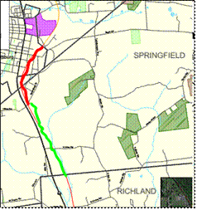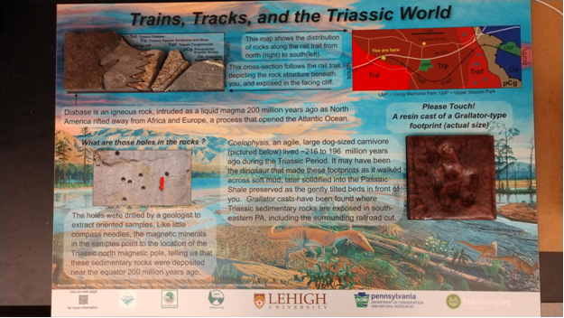

Table with listing of amenities

The PLPB is considering installation of watershed signs at the watershed boundary near the south end of the boardwalk. Walking south would indicate entering the Tohickon Watershed. Walking north may indicate entering the Saucon Watershed.

The PLPB is considering installation of county signs at the Bucks / Lehigh County boundary point.

Dog Station poles and Trash cans have been installed on the north and south side of North Mine Road.

Any formal use of the Trail in Springfield Township would need approval by the PLPB via the Permit Process in section 5.1.3.

Springfield Trail Rules – see Section 5.1

Springfield Township has signed a lease agreement for maintenance of the rail trail with Bucks County. This lease will dictate some aspects of the maintenance approach.

### Upper Bucks Rail Trail (UBRT) Management Units

UBRT will be managed by Springfield Township, but also in conjunction with Richland Township according to TBD Inter-municipal agreement with Richland Township.

Vegetation on the sides of the trail are expected to be mowed on a twice a year basis during the growing season. The trail is not expected to be maintained in the winter.

MOU with Coopersburg Borough and Upper Saucon Township for access to the northern portion of the trail beyond the boardwalk including the dinosaur kiosk and the county line.

The trash cans and dog stations along side North Mine Road will be maintained as amenities.

# Programs

## Youth Projects

The PLPB will support local youth related groups (e.g., Boy Scouts, Girl Scouts, 4H) and work with Leaders and youth for service projects.

## Community Day

The PLPB intends to continue to support Springfield Community Day by sponsoring a booth at the event. The intention is to allow open communication with the public as to current park and land preservation activities and gathering feedback from the community.

## Volunteers / “Friends of the …”

The PLPB has benefited from generous citizens that volunteer their time in support of Parks and Land Preservation. Because of the support, the PLPB is able to offset Operations and Maintenance costs and therefore request fewer budget funds annually from the Board of Supervisors.

An electronic newsletter is sent to individuals that have volunteered their email addresses for the purpose of sharing Parks and Land Preservation related information and volunteer work days.

## Art in the Park – TBD

The PLPB invites members of the community to capture images of the park in different media (e.g., photography, drawing, painting) as part of an annual contest. Images may depict anything at the park.

## Springfield 5K / fun run – TBD

The PLPB would consider coordinating recreational activities.

## Bird / Nature walks – TBD

Springfield Township is officially a Birdtown, USA as sponsored by the Audubon Society. The PLPB will work with the Environmental Advisory Council (EAC) to sponsor activities related to birding and bird watching. Additionally, guided nature walks / sessions will be another avenue of PLPB programs.

## Donations and Sponsorships

The PLPB has benefited from generous support of township residents.

## Memorializing Citizens on Township Property–

The Board of Supervisors adopted Resolution 2018-4 on May 8, 2018 to provide policy and procedures for memorializing citizens on Township owned property, to include its parks and Township controlled recreation facilities.

# Fiscal Responsibility

The PRB has been chartered with performing duties in a fiscally responsible manner. Springfield Township is small and budgets are typically not large enough to accomplish all Park and Recreation wants and needs. It is incumbent on the PRB to manage efforts carefully and making the most of volunteer effort and donations is prudent.

Another aspect of managing the facilities is to adjudicate possible conflicts of usage within the Parks and Recreation system. This may include maintenance activities, planned work by the hay lease farmer, programs (e.g., 5K run, 1 mile fun walk, outdoor led nature walks), other municipal activities (e.g., police fitness tests), and possibly in the future, reservation of portions of the park for township residents (e.g., wedding photos).

## Permitted Uses

### Peppermint Park Rules

1. The park is open to the public only during the hours of day light (dawn to dusk), or as otherwise posted by Springfield Township.
2. Drinking and/or possession of alcoholic beverages is prohibited.
3. Intoxication, indecent language, disorderly conduct, or other nuisance behavior is prohibited.
4. All pets brought to the park must be controlled on a leash and not be a nuisance or a danger to other park users. Pet owners are required to remove their pet’s fecal deposits from the park grounds and place their waste in a suitable receptacle.
5. Building fires, hunting, trapping, camping, horseback riding, driving golf balls , operating off-road vehicles (e.g., ATVS, 4 wheelers, motorcycles), and riding snowmobiles are prohibited.
6. The possession or use of firearms, crossbows or weapons of any kind is prohibited.
7. Damaging, defacing, or removing any park property is prohibited.
8. Littering is prohibited. Glass containers of any kind are prohibited. All rubbish must be placed in park receptacle(s).
9. Non-official motorized vehicles are to be parked and operated only in designated areas. Motorized vehicles are prohibited when park is closed. Official vehicles are Township, Municipal, and PRB authorized.
10. For the promotion of health and wellness, smoking is not permitted on park property.
11. Individuals using park facilities assume personal responsibility and risk.
12. Selling of food, concession or solicitation of any kind is prohibited without a permit from Springfield Township.
13. Individuals should not enter, exit, or establish access to the park through neighboring properties. Stay on the maintained paths.
14. Do not drive, operate or use a bicycle or mountain bike in an unsafe or hazardous manner. Yield right-of-way to other trail users – remember that pedestrians and runners are more vulnerable trail users.
15. All signs except those established by Springfield Township are prohibited.

### Upper Bucks Trail (UBRT) Rules – Springfield Section

No person shall commit any of the following acts within the Park / Rail Trail system:

1. Engage in any violent, abusive, loud, boisterous, vulgar, lewd, wanton, obscene or otherwise disorderly conduct tending to create a breach of the peace or to disturb or annoy others, while in or on any property administrated by or under the jurisdiction of the Township.
2. Possess or be under the influence of any alcoholic beverage while in or upon any property administered by or under the jurisdiction of the Township.
3. Possess or be under the influence of any illegal drug or narcotic while in or upon any property administered by or under the jurisdiction of the Township.
4. Throwing or propelling stones or missiles of any kind.
5. Hitting or driving golf balls.
6. All pets brought to the park must be controlled on a leash. All fecal matter shall be bagged and removed by the owner.
7. Horses are prohibited on the Trail.
8. Littering is prohibited. All rubbish must be placed in park receptacles.
9. Peddle or solicit business of any nature or collect any funds for any service of charity, or to distribute handbills or other advertising matter, to post unauthorized signs on any property administered by or under the control of the Township without first obtaining a permit from the Township.
10. Setting off, or discharging any firearms, air rifles, air pistols, sling shots or fireworks, including sparklers
11. Drive, operate or park any motor vehicle including but not limited to, recreation vehicle, ATV, snowmobile, dirt bike, and unlicensed vehicles with motors in or on any real estate
12. Drive, operate or use a vehicle or vehicular device in such a manner as to constitute “trick riding”, or in an unsafe or hazardous manner
13. Unless authorized by the Township or PRB, operating off-road vehicles is prohibited.
14. Obstructing, in any way, either totally or partially, any of the paths or roadways in said recreation places.
15. Entering or leaving any recreation place by motor vehicle except at the establishing and designated ways of entrance and exit
16. Cut, remove, or destroy any trees, sapling, seedling, bush or shrub, whether alive or dead, or chip, blaze, box, girdle, trim or otherwise deface or injure any tree or shrub, or pick, gather, uproot, remove or destroy any flower, plant or grass, except with a permit issued by the Township.
17. Remove or cause to be removed or to dig any sod, earth, humus, peat, boulder, rock, gravel or sand, except with a permit issued by the Township.
18. Posting or displaying any sign, banner, or advertisement of a political or commercial nature.
19. Building, starting or lighting any fires except at those places or structures provided therefore.
20. Injuring or destroying any wildlife.
21. Defacing, writing upon, or mutilating any notice posted within the recreation places by order of Township officials.
22. Camp, except in such areas as may be provided and designated for such purposes by the Township. No person or group shall camp without a permit issued by the Township.

### Permit Process

As the Parks and Land facilities gain usage there will need to be a transparent way to manage usage and avoid conflicts. Springfield residents may request a permit of usage from the PLPB. For special events that would restrict or modify public access, the PLPB will forward a completed, approved permit to the BoS for awareness.

This section augments the township policy for use of Township Property.

# Appendix A – Maintenance Unit Types

## Management Types by Facility

Table below provides a high level view of maintenance type with indication of what is planned to be used at individual facilities.

|  |  |  |  |  |  |
| --- | --- | --- | --- | --- | --- |
| Management Type | Peppermint Park | Upper Bucks Rail Trail | Lime Kiln | Flagpole Garden | TBD |
| Turf-Grass | Yes | No | Yes | Yes |  |
| Meadow | Yes | No | No | No |  |
| Hay Lease | Yes | No | No | No |  |
| Rain Garden | Yes | No | No | No |  |
| Trees | Yes | Yes | Yes | Yes |  |
| Ridge-top Barrens | Yes | No | No | No |  |
| Shrubs | Yes | Yes | No | Yes |  |
| Pervious Surface | Woodlot Trail | Aggregate Trail | No | No |  |
| Paved Areas | Yes | Yes | No | No |  |
| Invasive | Yes | Yes | Yes | Yes |  |
| Woodlot | Yes | Yes | No | No |  |
| Deer and Wildlife | Yes | Yes | No | No |  |
| Storm water inspection (last / next) | 2015 / 2016 | TBD | No | No |  |
| Amenities | Waste, Recycle | Waste, Recycle | No | No |  |
| Reforestration Area | Yes | No | No | No |  |

## Management Types

### Turf-grass Management

Turf grass areas that are mowed (i.e. Mowed paths) and contained within the Hay Lease areas may have *collateral* fertilizer application as part of the larger Hay Lease area management (see section 6.2.3). Mowed paths will not independently have fertilizer application.

The mowed paths will be cut approximately every 7-14 days during growing season. Cutting frequency will be less at start and end of season.

|  |  |
| --- | --- |
| Turf Grass Management | |
| Mowing and Trim | Satisfactory turf coverage will be mowed and trimmed as needed to maintain a height-of-cut (HOC) between 2.5” and 4”. Clippings will be side discharged or mulched into the turf canopy. |
| Seeding | Thin or bare areas deemed unacceptable will be documented and addressed by priority. Renovation will consist of soil cultivation, seeding, and possibly fertilization using a “starter” type product. Methods of renovation will be determined by site restrictions, equipment, labor, and material availability. |
| Herbicides | Obstructions requiring hand trim work (such as: fences, permanent structures, and other immovable objects) will be assessed. The areas may be treated with non-selective herbicides to reduce labor inputs, or alternative methods used (e.g., small stones / sand). This management type is not expected to be used in Peppermint Park. |
| PGR’s | Plant growth regulators (PGR’s) may be utilized on turf areas to reduce labor requirements. This management type is not expected to be used. |

### Meadow Management

Meadows should be mowed to a height (typically 4-6 inches during the first year) just above the tops of the native grasses, which are growing below the weeds and annual grasses. During the second growing season only 1 to 2 of perennial invasive such as Canada thistle may require the use of broadleaf herbicide (e.g., stinger) or manual eradication in addition to mowing. Following establishment, meadows should be mowed once a year during early spring (April). Unless additional mowings are required to prevent thistle, mugwort, spotted knapweed or other invasives from going to seed. Early spring mowings provides winter habitat, as well as a sequence of blooming wildflowers.

Meadow areas reserved for wildflowers (such as inside paved path of Peppermint Park) will not have herbicide applications.

The meadow fragment surrounded by the paved walking path at the park is a unique and special habitat as an excellent example of an original plant community within the Reading Prong of the Northeastern Highlands physiographic region. Maintained purely by annual mowing for more than 50 years, the plant species present within the meadow fragment represent those that would have been present before the arrival of European settlers. Several plant species growing in the meadow fragment are quite difficult to find elsewhere in the region and play an important role in the survival of the Monarch butterfly and other indigenous insects: Monarda fistulosa, Asclepias _merican, Sisyrinchium mucronatum, and Solidago speciosa.

### Hay Lease Management

Hay Lease area managed initially per Contract.

Lease requires farmer to obtain BOS approval (in collaboration with PLPB) for fertilizer treatment. Preference is for organic fertilizer treatments. Public notice must be given prior to fertilizer treatments. Pesticides and Herbicides are not to be applied in Peppermint Park as part of the Hay Lease. Soil Tests should be performed on a periodic basis to understand soil health and content for better management.

### Rain Garden Management

Storm-water management BMP shall be maintained on an annual basis for the first two years following completion of construction. Accumulated sediment within forebay or main rain garden can be removed by hand (e.g., with a shovel) or by using a small rubber tire or rubber tracked loader such as a “bobcat”. BMP can be mowed annually on the same schedule as meadow areas following establishment of plantings within them. Alternatively, if BMP hydrology results in a more wetland type community, annual mowing may not be desirable. Since pollutant removal efficiencies will be enhanced by leaving vegetation un-mowed, as the site becomes more stabilized, less sediment should accumulate annually within the BMP and the frequency of maintenance can be adjusted to maintain the BMP designed storage volume and function as a sediment trap. If BMP are maintained on a 3-5 year schedule (or longer), the top layer of plants, roots, and seeds can be stockpiled and replaced after excess underlying sediment is removed to regain lost storage volume.

Inside the rain garden and forebays will not be mowed (exception is the landbridge between the rain garden and the forebays which will be mowed).

A rain garden is a more natural alternative to a storm water basin, sometimes referred to as green infrastructure. It is intended to showcase a collection of the best moist-to-wet soil plant species indigenous to Bucks County including Alnus serrulata, Cephalanthus occidentalis, Rosa palustris, Aronia melanocarpa, Sambucus _mericana_, Salix sericea, the edible Apios _mericana (groundnut), and several representative wetland flower species. The plant collection is meant to inspire homeowners to explore the beauty of our common and uncommon native plant species by planting them on their own properties.

### Tree Management

There are numerous native Tree Types in the Township Parks and Recreation system. Non-native trees will be reviewed for possible removal or identification as a specimen tree.

For new tree plantings, PRB will endeavor to use Native Species recommended from SALDO Appendix E.

PLPB will adhere to Buffer Requirements from Zoning Ordinance

Guidelines for maintenance by type

Proper pruning, fertilization, weed control, and water management will all result in plant material and overall landscaping that are aesthetically pleasing.

Any heritage trees on the site may be subject to entry into the county sponsored program.

### Ridge-top Barrens Management

Several ridge-tops in Upper Bucks still contain remnants of plant communities that would have once dominated the area several thousand years ago and that now only exist in abundance in the Poconos. Peppermint Park retains a small area that is representative of this barrens-like plant community on the Deer Trail Road side of the hill from the parking lot (see map in Park section). This type of plant community emerges on very thin soil that typically overlays a granite outcrop and features diminutive plant species that are difficult to observe elsewhere in the region, including Danthonia spicata. This unusual area is under threat from both invasive non-native plants, sediment deposition, and by forest encroachment.

This unique area in Peppermint Park is intended to be managed to allow it to continue. The PLPB intends to allow reforestation of a section to the north, and annual meadow mow to the south so as to allow continued sun access from the south.

### Shrub Management

There are numerous Shrub Types in the Township Parks and Recreation system. Non-native shrubs will be reviewed for possible removal or identification as a specimen shrub.

For new tree plantings, PRB will endeavor to use Native Species recommended from SALDO Appendix E

PLPB will adhere to Buffer Requirements from Zoning Ordinance

Guidelines for maintenance by type

Proper pruning, fertilization, weed control, and water management will all result in plant material and overall landscaping that are aesthetically pleasing.

### Pervious Surface Management

Trail Types

|  |  |
| --- | --- |
| Pervious Surface Management | |
| Woodlot trail | The woodlot trail shall be maintained as wood chips. Small branches and cut saplings will be placed on the sides to help delineate the trail. |
| Aggregate trail | Trail will be top dressed and compacted with matching material to maintain a surface free of ruts or other tripping hazards. Stabilization of surface material may be achieved using various products in areas that consistently experience water erosion. |

### Paved Area Management

Debris deposited on pavement surfaces shall be swept and collected on a monthly basis. Damaged pavement areas shall be removed and replaced with new paving to prevent further erosion and off-site migration of sediment.

Paved areas are estimated to have a 30 year lifespan. Seal-coating may be performed at an intermittent point to extend the wear life of the paved area. The table below indicates when paved areas were first installed and any projected seal-coating.

|  |  |  |  |
| --- | --- | --- | --- |
| Park and Recreation Facility | Approximate size | Pavement installed | Seal-coating Performed |
| Peppermint Park – Parking Lot | 1130 square yd | June 2015 | TBD |
| Peppermint Park – Paved path | 8ft x 0.21 miles  (986 square yd) | June 2015 | TBD |

### Invasive Management

A long-term program to control invasive plants within naturalized areas includes annual inspections of meadows, ponds and basin (during the growing season) to identify and remove invasive vegetation. Some plants (e.g., trees, large shrubs) can be physically removed. However, herbaceous species and vines (e.g., Japanese honeysuckle, common reed, Canadian thistle) may require the use of a herbicide to achieve effective long-term results. Any herbicide application will require approval of the PLPB, with preference for organic versions. Cattails, although native species, are not included as part of the long term vegetation of pervious areas and the basin, and should be removed from such facilities, and Best Management Practice (BMP) facilities, at least until installed vegetation has become well established. Otherwise, these aggressive species will overgrow and kill off the installed vegetation and form undesirable monocultures.

List of invasive plants:

Japanese Barberry

Multi-flora rose

Miscanthus

Autumn Olive

### Woodlot Management

Woodlots are managed in a different way than individual trees.

### Deer and Wildlife Management

Although entirely native, white-tail deer represent a challenge similar to invasive exotic plants. In areas of excessive deer damage, consideration should be given to installing a deer fence around any plantings during the plant establishment period. When this fence is removed, all available options to control deer population should be considered. Options may include bio-safe liquid deer fencing.

### Storm-water Management

All storm-water management and water quality facilities shall be inspected by the owner (Township) annually and after any storm event larger than the one year frequency (probability) storm event.

Storm-water control BMPs shall be inspected on the following basis by the township:

* Annually for the first five (5) years.
* Once every three (3) years thereafter.
* After the cessation of a 100-year storm event.

Written reports of inspection findings and any repairs completed must be maintained by the township for each inspection completed.

### Site Amenities

* Trash / Waste

Trash receptacles on site shall be inspected on a biweekly basis and removed to allow capacity.

* Recycling

Recycling receptacles will be placed on site, co-located with trash receptacles, to encourage public recycling. Recycling receptacles shall be inspected on a biweekly basis and removed to allow capacity.

* DRAFT List of Items that other local Facilities have

Restroom

Drinking water, etc.

### Reforestration Area

Intent is to increase the woodlot aspect of space toward a fuller woodlot / forestation area. Invasive species will be removed to encourage native species growth.

# Change Log

|  |  |
| --- | --- |
| Date | Changes |
| 5 Nov 2015 | Initial Version  Identified Peppermint Park and Rail Trail as initial properties for PRB to manage. |
| 5 Feb 2016 | Expanded Management Unit Types and indication of Management Units for Peppermint Park. |
| 12 Nov 2016 | Updated descriptions for Programs – Included Youth Projects. |
| 14 Jan 2017 | Updated Park management map and added Ridge-top Barrens biome to Peppermint Park. Added information about Lime Kiln on Woodbyne Road. Added draft Rail Trail rules. |
| 10 April 2017 | Plan approved by PRB at 10 April Meeting. |
| 21 Oct 2017 | Added Park rule #15 which was approved at 10 July 2017 PRB meeting. |
| 15 January 2018 | Added Bench Program as TBD. Bench program was approved as draft at 15 Jan 2018 PRB meeting. Updated descriptions for Peppermint Park, Lime Kiln, and Rail Trail to reflect progress. Updated Management Unit descriptions. |
| 14 May 2018 | Plan approved by PRB at 14 May 2018 meeting. |
| 11 May 2020 | Plan reviewed by newly formed PLPB. |
| 22 January 2021 | Updated to PLPB. Added Flagpole Memorial Garden. Added Reforestation management type. Clarified definition of Parks to include trails. Added UBRT as dedicated. Updated wording from future tense for items that have taken place. Plan reviewed at Feb PLPB meeting, with expectation to be provided to Board of Supervisors for concurrence with PLPB approval. |
| 10 May 2021 | Addressed EAC March 2021 comments on the plan. Plan approved at 10 May PLPB meeting. |